1 Purpose of this Document

1.1 Scope
This document defines the intended use, scope, risks, validation approach and evidence needed to establish that EUDAMED Loader is suitable for its use at Blatchford. It links business needs to system requirements and planned tests, and provides a record of the results, deviations and approval decision.

EUDAMED Loader supports the preparation, checking, registration and updating of Blatchford medical-device data for EUDAMED and retains the resulting registration evidence. The scope covers preparation of the Import workbook, import into the application database, review of device and parent details, generation of single and bulk XML submissions, and import of the responses returned by EUDAMED.
This validation scope includes the production application [EUDAMED Loader] and the separate Dev/Playground EUDAMED environment used for testing. Configuration settings determine the intended EUDAMED environment, the schema package, actor details and the application data used for that environment.

The application checks generated XML against the configured EUDAMED schema set and allows the XML to be downloaded in a ZIP file. The Operator reviews the generated files and uploads the XML separately through the relevant EUDAMED Portal. EUDAMED processes the uploaded files and returns the submission outcome.

The Operator must retain and import the returned EUDAMED responses into EUDAMED Loader so that the application records the registration or update outcome. The application has no direct connection to EUDAMED; its recorded registration status depends on the source registration evidence and responses imported into it.

Validation includes the environment configuration, supplied schema packages, source-data and mapping rules, database storage, backup and recovery arrangements, and operating procedures where they affect the intended use.

Automated submission or machine-to-machine (M2M) integration, automated response polling and live synchronisation with EUDAMED are outside the current scope.

1.2 References
Table 1 Referenced Documents
Document Number | Title
BQP 07-12 | Software Validation

1.3 Terms and Abbreviations
Term | Meaning
Basic UDI-DI / parent | Issuer-qualified parent identifier grouping related device records.
Device UDI-DI / child | Issuer-qualified identifier of a device record linked to a Basic UDI-DI. Catalogue number is selection context, not regulatory identity.
POST / seed | DEVICE.POST registers a new parent with its first child; UDI_DI.POST adds a child under an existing parent.
PATCH | UDI_DI.PATCH updates an already registered child using the supported scenario and latest accepted state.
Market Information PUT | MARKET_INFO.PUT changes the accepted countries with a separate Market Information version.
Accepted baseline | Trusted imported Production export evidence or a matched successful response supporting the current accepted device/market details.
Preview / ZIP review / acceptance | Separate states: a preview checks XML; a successful requested ZIP download records review of that exact package; EUDAMED acceptance is established by the matching successful response.
UAT / deviation | User Acceptance Testing / a documented departure from an expected result requiring investigation and disposition.
Validation baseline | Identified code, configuration, dependencies, schema, inputs, procedures and environment against which execution evidence is collected.
QA | Quality Assurance
Asset Owner | the accountable business owner of the application and its information; named approvers to be assigned through document control.

2 Software Scope

2.1 Background
Regulatory Affairs obtains and checks the EUDAMED registration XML extracts, device Template workbooks and Basic UDI-DI workbook, prepares and reviews the Import workbook, and assesses and imports the data into EUDAMED Loader. Regulatory Affairs checks the imported information before it is made available for submission activities. Operators then select devices, review and download the XML packages, upload the XML through the relevant EUDAMED Portal service and use Upload Success XML to record the returned responses.
The application keeps the supplied device details separate from the registration details confirmed by EUDAMED. Registration of a Basic UDI-DI parent does not mean that all associated devices are registered. Registration status is also separate from whether a record contains sufficient information to generate XML. Where registration status cannot be established, it must remain unknown until supporting information is available. Changes made directly in the EUDAMED Portal or responses that have not been imported can leave the application records incomplete.

2.1.1 Intended use: who, what, when, why, where and how
Question | Answer
What problem is addressed? | Prepare consistent EUDAMED device information from multiple sources, control parent/child registration and updates, and retain a traceable view of recorded outcomes.
Why is the software useful? | Reduces repeated manual data handling and provides identity, readiness, XML-validation, accepted-state and version safeguards across single and bulk operations.
How does the software solve the problem? | Regulatory Affairs obtains and checks the EUDAMED registration XML extracts, Template workbooks and Basic UDI-DI workbook, prepares and reviews the Import workbook, assesses and imports the data, and checks the results. The Operator then selects the devices, reviews and downloads the XML, uploads it through the EUDAMED Portal, imports the returned responses and checks the recorded outcomes.
Who uses the software ? | Regulatory Affairs owns source-data preparation, review and import, including the EUDAMED registration XML extracts, Template workbooks and Basic UDI-DI workbook, and confirms the business information and registration activities. Enterprise Solutions provides application maintenance and technical support. Trained operators carry out XML loading.
Where is the software used? | The currently configured local Blatchford application environment, browser frontend and backend/database locations, with separate Dev/Playground and Production profiles. Deployment hostname, OS/browser versions and access arrangements must be recorded for execution; wider hosted rollout is not assumed.
When is the software used? | When, new parents/children need registration on EUDAMED, accepted device/country details need updating, or recorded outcomes need review.

2.2 Regulatory use assessment
The application supports medical-device regulatory data management within the Blatchford quality system. EUDAMED provides a further validation control after upload: XML that fails the schema requirements applicable to the selected environment is rejected, and records that fail its enforced business rules are not accepted. A bulk submission can contain both accepted and rejected records, so the returned outcome must be checked for each device.
The Loader checks XML against its configured schema before download. EUDAMED then applies its own validation and business rules, including checks against information already held in EUDAMED.
These controls substantially reduce the risk of schema-invalid or business-rule-invalid data being accepted by EUDAMED. A rejection requires Blatchford to investigate and correct the source information, application configuration or XML generation as appropriate, review the revised XML and resubmit it. EUDAMED acceptance confirms that the submitted record passed the checks applied by the service. It does not independently confirm that every device detail is factually correct.

Requirement / source
BS EN ISO 13485:2016 clause 4.1.6

2.2.1 Determine the role that the software plays in support of these regulations.

The Loader prepares electronic registration records and manages identity, accepted-state lineage, versions and response evidence. The application does not automate the registration of the devices.

2.3 Processes and software extraneous to medical device regulatory requirements

N/A – Application/process scope not extraneous to the medical device regulatory requirement.

2.4 Risk levels
Risk area | Potential failure / consequence | Controls
Identity and coverage | Missing/duplicate Device UDI-DIs, wrong issuer or parent, omitted source population or unintended inclusion. | Review confirmed source coverage; preserve issuer-qualified identities and provenance; exercise duplicates, parent-only records, exclusions and unknown status.
Regulatory content and lineage | Incorrect registration/update content, wrong accepted baseline, stale version or loss of accepted countries. | Scenario/eligibility checks, per-device baseline/version derivation, before/after review by Regulatory Affairs, XSD validation and response verification; test first and later updates.
Evidence and recorded status | Preview mistaken for acceptance, wrong-response correlation, delayed/duplicate response rollback or partial outcome misreported. | Separate review/acceptance states, exact package context, matched response handling and per-device reconciliation, including error and late-response cases.
Environment and data security | Production/Playground confusion, wrong actor, unauthorised file/database access or supply-chain/configuration change. | Confirmed banner/profile isolation, company access arrangements, controlled dependency/configuration changes and security review. Technical access-control adequacy requires a recorded assessment.
Availability and recovery | Corrupt/lost SQLite state or missing ZIP/response/source evidence prevents reconciliation. | Back up/Recovery of application to be inline with BQP 08-01 MIS Back up procedure as production will loaded on the cloud.

No risk to humans because this software registers device details only and has no impact whatsoever on design or operation of medical devices. The risk of the software is low limited to regulatory risk with mitigations as discussed above.

3 Validation Strategy / Planning

3.1 Test strategy and rationale
The test strategy combines automated regression testing with user acceptance testing (UAT) carried out by Head of Enterprise Solutions using the EUDAMED Playground. Playground testing has been used extensively during development to check that generated XML is accepted by EUDAMED, investigate rejected submissions and refine the application controls. The recorded UAT results provide supporting evidence for the intended registration and update workflows. Remaining validation activities are selected against the requirements in Appendix A and the identified risks.
Activity | Approach | Evidence to retain
Requirements and risk review | QA, Regulatory Affairs, Enterprise Solutions and representative Operators review scope, responsibilities, risks and acceptance criteria. | Approved requirements/traceability and risk disposition, including any applicability decisions.
Baseline / installation verification | Record code, dependencies, profiles, schema hashes, actor details, isolated database, backup paths, workstation/browser and WI issue. | Configuration/baseline record with date, performer and review; no secrets in the evidence.
Automated regression | Run the backend/frontend checks appropriate to the frozen baseline and preserve complete outputs. Link relevant test cases to intended-use requirements. | Commands, logs, counts, failures, versions and exact baseline; build output and review of warnings.
Operator UAT | Execute Appendix B with representative synthetic records in isolated databases; use Playground for controlled external service testing. Production checks require explicit approval and suitable selected records. | Actual results, screenshots, XML/ZIPs, file hashes, portal references where applicable, original responses and performer/reviewer details.
Negative / recovery testing | Exercise unresolved identities, blocked actions, malformed/rejected or unmatched responses, partial/duplicate/late outcomes, transaction failure and restoration. | Per-case expected/actual results, deviations and proof that unrelated or newer accepted state is preserved.
Results and acceptance review | Resolve deviations or obtain documented risk-based disposition; verify traceability and operating controls. | Completed result summary, reviewed deviations, residual risks and QA/asset-owner approval. No automatic acceptance based on test totals alone.

3.1.1 EUDAMED Playground user acceptance testing
Head of Enterprise Solutions performed UAT using individual and bulk XML submissions to the EUDAMED Playground. The testing covered creation of new Basic UDI-DI parents and seed devices, registration of additional Device UDI-DIs, single and bulk PATCH updates, and Market Information updates. Returned EUDAMED responses were reviewed to establish the outcome and inform further development and testing.
The retained Playground application history reviewed on 22 October 2026 records 417 successful registration or update test outcomes across 215 distinct device records, dated 9 August to 5 October 2026. Testing included successive operations and versions for selected devices. The successful outcomes are summarised below.
XML message type | Successful individual outcomes
DEVICE.POST — new parent and seed device | 10
UDI_DI.POST — additional devices | 205
UDI_DI.PATCH — device updates | 137
MARKET_INFO.PUT — Market Information updates | 65
Total | 417

The 417 successful tests are counted at the individual registration or update outcome level. A bulk upload can contain multiple device records and therefore produce several successful test outcomes. These figures cover the four XML message types and do not represent 417 separate uploads.
During UAT, unsuccessful submissions were investigated and used to refine the application operation, XML generation and checks. The application was updated and further testing carried out, establishing the recorded evidence of 417 successful outcomes. This iterative approach helped confirm the registration sequence, supported updates, version handling and Market Information requirements.
Retain the submitted XML, original EUDAMED responses, test subjects, dates and software/configuration details as supporting UAT evidence in the controlled validation records. Link this evidence to the relevant requirements and identify any testing that needs to be repeated against the final release. These successful UAT outcomes support validation; final validation approval remains subject to review of the complete evidence and required approvals.

3.1.2 Rationale for sample selection
Use coverage-based sampling, not an arbitrary percentage of the live database. Each protocol in Appendix B must include its stated branches and boundaries. Select representative single devices and multi-device batches with different accepted versions/country baselines, multiple parents or issuer distinctions where relevant, and controlled invalid inputs. Exercise configured batch/chunk boundaries without assuming an unsupported batch size.
Include newly registered parent/seed and subsequent children; imported Production baselines at more than one accepted version; registered/unregistered/unknown identities; changed existing and unchanged import rows; skipped rows; supported PATCH scenarios; different Market Information starting states; and successful, failed, partially successful, duplicate and delayed responses. Exact sample identifiers, counts and expected results must be agreed and recorded before execution. Dev and Production profile behaviour must both be covered where it differs.

3.2 Validation results
Result item | Current recorded position
Development backend regression | Recorded 21 October 2026: 293 tests passed in 236.66 seconds; two FastAPI startup deprecation warnings. Obtain the complete log and tie it to the execution baseline before relying on it for formal acceptance.
Frontend / production build | Recorded 22 October 2026: 98 frontend tests passed and TypeScript/Vite build passed; existing JavaScript bundle warning (>500 kB, 777.84 kB at that checkpoint). These are not browser end-to-end execution results.
Targeted defect evidence | Shared Bulk PATCH / Bulk Market Info parent-selector fix 3ec14d4: synthetic regression coverage and dated read-only Aqualimb TF comparison. No Production state was altered by the diagnosis.
WI review | Operator WI created error handling completed and diagrams/spacing checked at package level. Confirm controlled issue, training and visual pagination review for validation use.
Formal UAT / deviations / approval | Not yet executed/entered against the approved validation baseline in this document. Complete Appendices A–C, record deviations and obtain QA/asset-owner decision before declaring validation complete.

4 Software Lifecycle
Enterprise Solutions maintains the application and its configuration and provides technical support. Regulatory Affairs owns the process for obtaining, checking, preparing, reviewing and importing the EUDAMED registration XML extracts, Template workbooks and Basic UDI-DI workbook, and confirms corrections to the supplied information. Operators retain submission and response evidence and escalate issues under the WI. Changes are reviewed for their effect on intended use, data accuracy, security and retained records before release under the company process.

4.1 Revalidation approach at Blatchford
The revalidation approach is limited to requirement changes enforced by EUDAMED e.g., XML schema changes or changes to the application functionality requested by the Regulatory Affairs team. The application functionality is limited to the provided schema from EUDAMED meaning level of customization functionality available to the application Operator is minimal.

5 Dependencies, Risks and Assumptions
Dependency / assumption | Required control or open decision
Source accuracy and completeness | Regulatory Affairs confirms business content, scope, parent details and export query coverage. Import/validation does not certify an incomplete export as the entire EUDAMED inventory.
Manual process | Operators use the correct portal/actor/service and import every response. Direct portal edits or missing acknowledgements can make local state stale; reconcile before dependent actions.
Host and access controls | Confirm authorised access to application endpoints, source files, database, backups and credentials, together with workstation/network protections. Procedural roles alone do not demonstrate technical authorisation.
Backup and retention | Confirm repository, access and retention arrangements; execute restore and reconciliation tests. Downloaded packages and response originals must be retained outside metadata-only database entries.
Environment and package provenance | Use the correct separate database/profile/schema and record package hashes. The derived Dev package is not an official Production schema release.
Dependencies and security | Pinned top-level requirements do not establish the integrity of every transitive dependency or historical installation. Record the installed dependency inventory, review supplier/security changes and assess incidents through Enterprise Solutions/IT security.
Known limitations | Legacy records may lack complete accepted snapshots; catalogue/model identity collisions or unresolved source exceptions can block operations. Record their effect and disposition; do not silently fill missing accepted history from current workbook values.
Formal decisions still needed | QA/asset owner: regulatory applicability, formal risk rating, exact validation baseline, test sample approval, evidence repository, recovery/access adequacy, review interval and final acceptance. These are open validation decisions, not completed approvals.

5.1 User Documentation
Use the controlled EUDAMED Loader Work Instruction, with its PDF only where confirmed to match the approved Word issue. Record the instruction issue used and performer training in the validation execution records.

6 Validation History
Issue / record | Description
Initial preparation — 22 October 2026 | Template examples replaced with Loader-specific scope, risk considerations, validation plan, requirements and protocol/evidence registers. Formal execution and acceptance remain pending; controlled document issue to be assigned by the owner.

7 Approval

 | Name | Position | Signature
Complied By:
Reviewed By:
Approved By:
(approval at minimum asset owner)

Appendix A – User Needs and Requirements Traceability

Need / requirement | Business need | Acceptance requirements | Protocol
UN-01 / SR-01 | Identify the correct environment | Confirm profile, schema and actor details; isolate Dev/Production data and block unconfirmed context. | VP-01
UN-02 / SR-02 | Prepare and import reviewed data | Regulatory Affairs checks the source information, reviews the Import workbook and supporting checks, and assesses the data before import. Only eligible new devices are added. Repeating an unchanged import must not duplicate records or remove existing data. Differences in existing device details must be identified and resolved before import proceeds. Retain the import report and check the results. | VP-02
UN-03 / SR-03 | Preserve exact identity and scope | Resolve issuer-qualified parent/device identities, source lineage and duplicates; expose unresolved records; changing selections must not retain stale results. | VP-03
UN-04 / SR-04 | Register a parent with its first device | Generate DEVICE.POST for an eligible unregistered parent/seed and establish acceptance only from the matching response. | VP-04
UN-05 / SR-05 | Register additional children | Bulk POST uses UDI_DI.POST under an accepted parent; exclude registered children and review the included/excluded/chunked cohort. | VP-05
UN-06 / SR-06 | Update one or more registered devices | Single/Bulk PATCH resolves each accepted device independently, including imported baselines and seed devices; preserve individual eligibility/versions/countries. | VP-06
UN-07 / SR-07 | Update one or more market countries | Single/Bulk MARKET_INFO.PUT uses the full intended country list and separate next per-device Market Information versions. | VP-07
UN-08 / SR-08 | Review and retain exact XML packages | Preview/XSD checks are separate from successful ZIP review receipts and acceptance; retain exact downloaded bytes and submission context; failures must not leave partial generation history. | VP-08
UN-09 / SR-09 | Record and reconcile every response | Match acknowledgement identity/context; process success/error/partial/duplicate/late outcomes without false acceptance or rollback; failures are visible and escalated. | VP-09
UN-10 / SR-10 | Show trustworthy registration status | Separate parent/child and registration/readiness; count imported acceptance without fabricated upload successes; show unknown, scope and evidence limits. | VP-10
UN-11 / SR-11 | Preserve and recover controlled evidence | Protect retained records, demonstrate isolated database restore and retain/reconcile original source, package and response evidence. | VP-11
UN-12 / SR-12 | Operate under a controlled baseline | Record dependencies/configuration, access responsibilities, WI/training and change/risk decisions. Route source-data preparation, review and import queries to Regulatory Affairs, and application faults or technical issues to Enterprise Solutions. | VP-01, VP-11; lifecycle review

Appendix B – Validation Needs and Acceptance Criteria
VP-01–VP-11 define the verification needed for the intended use and the requirements in Appendix A. Each area states what must be checked, the acceptance criteria and the evidence required. Appendix C uses the same references and area names to record the corresponding testing results, supporting evidence and outstanding checks.

VP-01 — Environment and controlled setup
Verification required: Inspect baseline, profiles, schemas/actors, paths, browser and WI/training; exercise confirmed and unavailable/wrong environment cases.
Acceptance criteria: Correct environment is explicit; Dev/Production isolated; wrong/unconfirmed setup cannot be mistaken for approved Production execution.
Evidence required: Setup record, profile/schema hashes, screenshots and access-review record.

VP-02 — Preparation, import and repeat import
Verification required: Use a controlled test set of device Template workbooks, Basic UDI-DI details and EUDAMED registration extracts. Prepare and review the Import workbook and its supporting checks, assess and import the data, and check the results. Repeat the import with unchanged information, then with an additional device. Check how the application handles changed existing details, excluded records and incomplete, inconsistent or unavailable import files.
Acceptance criteria: The correct new devices are added, and their source and registration information can be traced. An unchanged repeat import creates no duplicates and preserves existing data and confirmed registration outcomes. Changes to existing details and problems with the import files are reported for review without leaving an incomplete import.
Evidence required: Copies or references for the source information, reviewed Import workbook and supporting checks, import assessment and report, and records showing the application data before and after import.

VP-03 — Identity, filters and success response
Verification required: Use parent/child and issuer distinctions, duplicate/catalogue conflicts and model/search scopes; change selection while assessment/preview/response actions are pending.
Acceptance criteria: No cross-device or stale response overwrites; ambiguous records are reported/blocked; current scope is retained and exact device identity remains traceable.
Evidence required: Selection screenshots, synthetic requests/responses and scoped results.

VP-04 — Parent and seed registration
Verification required: Select eligible unregistered parent; inspect Interpretation, DEVICE.POST XML and XSD; download exact ZIP; use controlled external submission where approved; import matching response.
Acceptance criteria: Only intended parent/seed included; download alone does not register; matching success records both identities and enables the next child step.
Evidence required: Assessment, XML/ZIP, portal/reference evidence where used, response and final state.

VP-05 — Bulk child registration
Verification required: Use registered parent with accepted seed and unregistered children; select specific children/presets; inspect exclusions/chunks; submit/import controlled outcomes.
Acceptance criteria: UDI_DI.POST only for eligible new children; seed/registered children excluded; package scope matches review; per-device outcomes recorded.
Evidence required: Selection/chunk evidence, package/manifest, responses and registration checks.

VP-06 — Single & Bulk PATCH
Verification required: Exercise single and bulk PATCH scenarios from accepted POST/imported and accepted PATCH state; inspect non-target fields/countries; include missing-current-baseline rejection.
Acceptance criteria: Correct next device version and targeted change; retained accepted details/countries; missing baseline blocked; matched response advances only accepted state.
Evidence required: Accepted baseline, comparison, validated XML/ZIP, response and version checks.

VP-07 — Single & Bulk Market Information
Verification required: Use different accepted country/version baselines; specify complete target list; exercise observed-version floor and unresolved market rejection; import controlled responses.
Acceptance criteria: Correct final countries and separate per-device Market Info versions; errors do not accept countries; device PATCH version unchanged; later PATCH retains accepted countries.
Evidence required: Current/target comparison, XML/ZIP, response, market/device version checks.

VP-08 — Package integrity and failure handling
Verification required: Compare preview and returned ZIP content/context; change selection/inputs; exercise archive/audit failure and concurrent state change in isolated tests.
Acceptance criteria: Review receipt tied to exact successful ZIP; no preview-as-acceptance; changed contents need review; failed/conflicting generation leaves no partial history.
Evidence required: Hashes, ZIP members/manifest, receipts, failure results and event counts.

VP-09 — Acknowledgement matching and exceptions
Verification required: Process matching success/error, mixed bulk results, duplicate/late responses, mismatched IDs and missing context; follow WI escalation.
Acceptance criteria: No arbitrary latest-draft matching or rollback; duplicate handling is controlled; each response retained/imported; failures stay unresolved and visible.
Evidence required: Original responses/IDs, events/state before/after, exception and resolution records.

VP-10 — Read models and registration counts
Verification required: Compare known imported/accepted identities with Registration State, Parents & Children and summary; test parent-only/unknown cases, filters, pagination and unavailable refresh.
Acceptance criteria: Parent and child counts/status are distinct and evidence-based; readiness separate; no fabricated success count or stale/zero display on failed retrieval.
Evidence required: Known expected counts, screenshots and query/API results with dates/scope.

VP-11 — Recovery, retention and operational handover
Verification required: In isolation backup and restore a known database with source/package/response records; verify recovered state and reviewed access/storage arrangements.
Acceptance criteria: Restored identities, accepted versions/history and retained artifacts reconcile; recovery gaps are recorded; Regulatory Affairs, Enterprise Solutions and Operator responsibilities and handover are understood.
Evidence required: Backup/restore procedure/log, integrity checks, artifact inventory, training/access decisions.

Appendix C – Validation Results, Evidence and Open Decisions
The results below correspond to VP-01–VP-11 in Appendix B and summarise the testing recorded in this document. Historical development test results and Playground outcomes provide supporting evidence. Recorded Pass results remain subject to review of the actual results, evidence and deviations against the corresponding Appendix B criteria.
The Head of Enterprise Solutions carried out extensive user acceptance testing using EUDAMED Playground. The retained history records 417 successful individual registration or update outcomes across 215 device records, covering all four XML message types.

Results against Appendix B
Appendix B reference / area | Testing results currently recorded | Outstanding verification / status
VP-01 — Environment and controlled setup | Playground setup and environment configuration were exercised during UAT. Automated checks cover environment reporting and unconfirmed-state handling. Supporting register references: EV-01, EV-02, EV-04, EV-05, EV-06 and EV-08. | See screenshot below as evidence of verification. Pass.
VP-02 — Preparation, import and repeat import | Automated preparation/import tests cover repeat import, additional devices, existing-data differences and preservation of confirmed registration information. Playground XML acceptance is separate from these import checks. Supporting register references: EV-01, EV-06 and EV-07. | See screenshot below as evidence of verification. Pass.
VP-03 — Identity, filters and success response | Automated testing covers identity, selection and stale-result safeguards. Playground UAT exercised selection of identified parent and device records. Supporting register references: EV-01, EV-02, EV-04 and EV-07. | See screenshot below as evidence of verification. Pass.
VP-04 — Parent and seed registration | Completed Playground UAT includes 10 successful DEVICE.POST outcomes for new parent and seed-device registration. Supporting register references: EV-04 and EV-07. | See screenshot below as evidence of verification. Pass.
VP-05 — Bulk child registration | Completed Playground UAT includes 205 successful UDI_DI.POST outcomes for additional device registration. Supporting register references: EV-04 and EV-07. | See screenshot below as evidence of verification. Pass.
VP-06 — Single & Bulk PATCH | Completed Playground UAT includes successful single-device PATCH updates, including storage conditions, trade name, critical warnings and base quantity, and successive accepted versions. These contribute to the combined total of 137 successful UDI_DI.PATCH outcomes. Automated tests provide additional baseline and state-protection coverage. Supporting register references: EV-01, EV-04 and EV-07. | See screenshot below as evidence of verification. Pass.
VP-07 — Single & Bulk Market Information | Completed Playground UAT includes 65 successful MARKET_INFO.PUT outcomes through individual and bulk updates. Recorded follow-on PATCH testing also demonstrated use of the updated Market Information. Automated tests provide additional version and state-protection coverage. Supporting register references: EV-01, EV-03, EV-04 and EV-07. | See screenshot below as evidence of verification. Pass.
VP-08 — Package integrity and failure handling | XML generation, download and upload were exercised during successful Playground UAT. Automated testing provides additional package-integrity and failure-handling coverage. Supporting register references: EV-01, EV-04 and EV-07. | See screenshot below as evidence of verification. Pass.
VP-09 — Acknowledgement matching and exceptions | Playground UAT exercised returned responses and refinement of response handling. Automated tests cover acknowledgement matching, duplicates, delayed outcomes and state protection. Supporting register references: EV-01, EV-04 and EV-07. | See screenshot below as evidence of verification. Pass.
VP-10 — Read models and registration counts | Registration information was reviewed during Playground UAT. Automated tests cover registration/readiness views, counts and imported registration evidence. Supporting register references: EV-01, EV-02, EV-03, EV-04 and EV-07. | See screenshot below as evidence of verification. Pass.
VP-11 — Recovery, retention and operational handover | A completed backup-and-restore demonstration is not established by the evidence reviewed for this document. Supporting register references: EV-05, EV-06, EV-07 and EV-08. | See description below. Pass.

Supporting evidence and open-decision register
Evidence ID | Available / required record | Status
EV-01 | Full backend suite: 293 passed, recorded 21 October; two existing startup warnings. | Recorded development test result; retain and review the complete test log and its link to the software version tested.
EV-02 | Frontend: 98 passed and TypeScript/Vite build passed, recorded 22 October; bundle-size warning. | Historical checkpoint; complete outputs and warning disposition to be retained. Browser UAT remains separate.
EV-03 | Bulk parent-selector correction 3ec14d4; seven new HTTP regressions and strengthened synthetic Production-import test. | Supporting development evidence; link exact test cases/results to VP-07/VP-08/VP-11.
EV-04 | Successful Playground UAT: 417 individual registration or update outcomes across 215 device records, covering DEVICE.POST, UDI_DI.POST, UDI_DI.PATCH and MARKET_INFO.PUT. Retain any Production registration evidence separately. | Supporting UAT evidence; retain the submitted XML, original responses and software/configuration details, and review differences from the final validation version. Historical counts do not represent a current registration inventory.
EV-05 | Current operator WI and formal training record. | WI populated; controlled issue/training and final visual review must be recorded.
EV-06 | Approved intended use, risk/applicability assessment, baseline, sample plan and protocol. | Required before formal execution; QA/asset-owner decisions not recorded here.
EV-07 | VP-01–VP-11 actual results, evidence files, deviations and corrective/retest records. | Retain the actual results and evidence supporting the recorded Pass entries, together with deviations, corrective actions and retest records. Complete the outstanding verification for the areas that remain open.
EV-08 | Access/security, backup/restore, records repository/retention and periodic-review decisions. | Required operational-control evidence; based on standard IT operations provision for cloud deployed applications with Blatchford Azure tenant.
EV-09 | Final traceability review, residual-risk disposition and approval. | Required to close validation; signatures and dates remain blank until authorised approval.

Supporting Evidence screenshots

VP-01 — Environment and controlled setup
The image shows the two application configurations: EUDAMED Production and EUDAMED Playground. Each application session uses one configuration at a time.
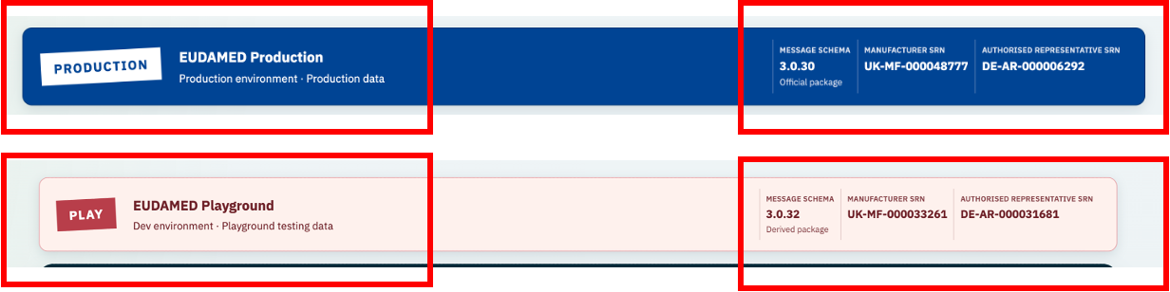

VP-02 — Preparation, import and repeat import
The image shows the Playground import process, which combines EUDAMED registration XML extracts, Template Excel workbooks and the Basic UDI-DI workbook. Regulatory Affairs is responsible for obtaining, checking and preparing these source files for import.
The application uses these sources to identify devices with recorded registration evidence and Template devices not represented in the supplied extracts. The completeness of this view depends on the coverage of the source files.
The example shows the selected source batch, containing 8,424 active Template devices, of which 241 appear in the supplied EUDAMED XML extracts.
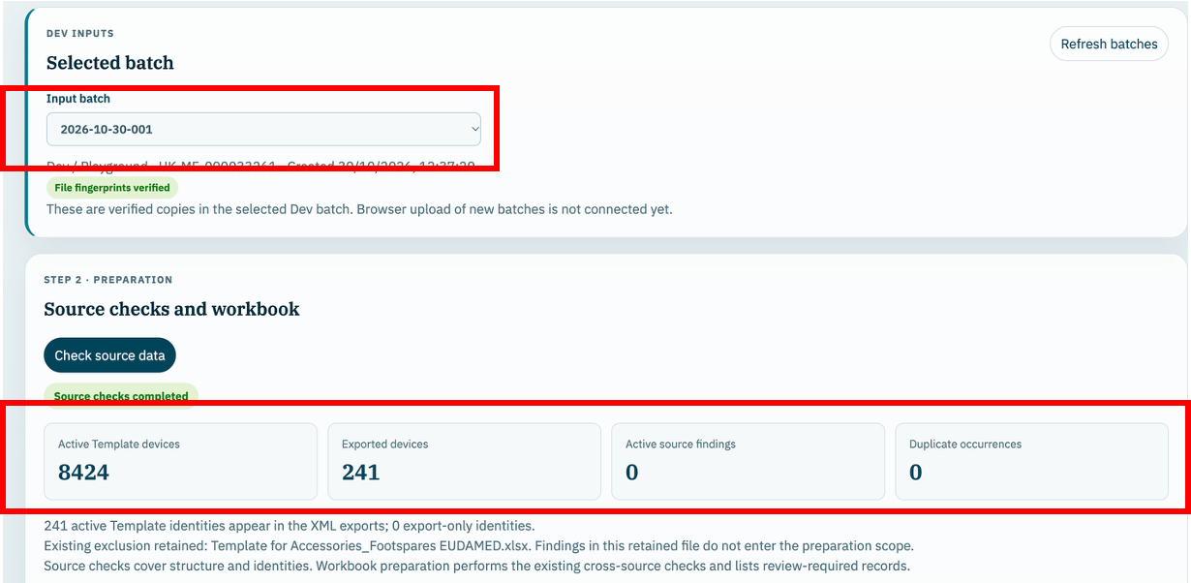

VP-03 — Identity, filters and success response
The image shows the Parents & Children view, which allows the Operator to inspect Basic UDI-DI parent records and their associated devices. Registered and unregistered child devices are shown separately, together with their XML eligibility. The view can be adjusted based on filters available in the user interface.
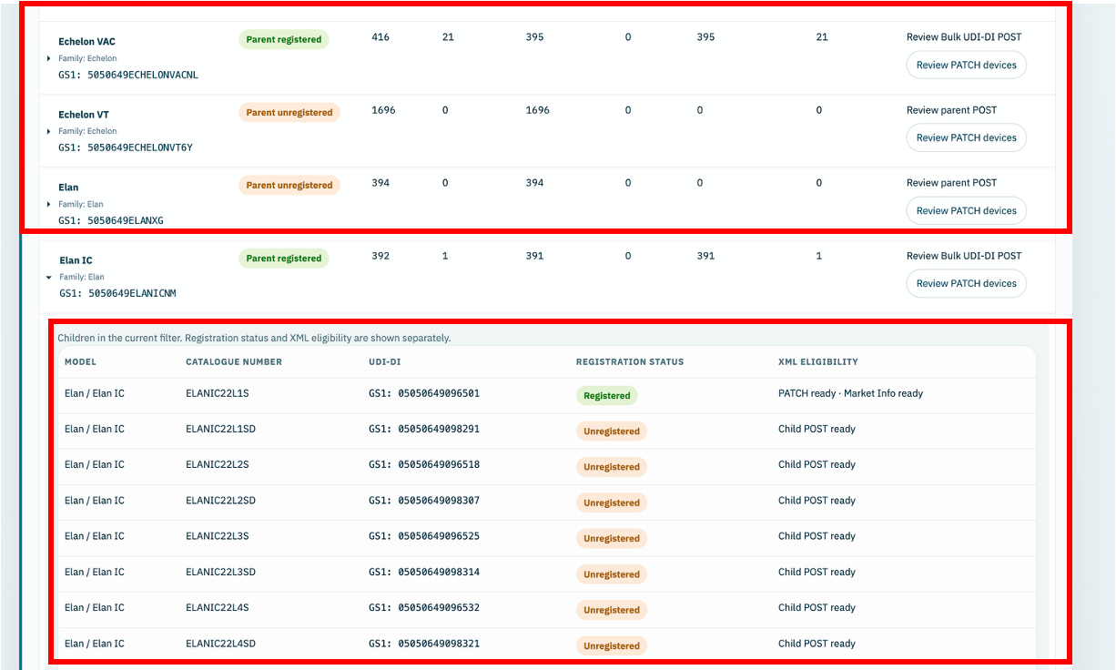

VP-04 — Parent and seed registration
The image shows selection of a device model and the Single POST assessment used to prepare registration of a new Basic UDI-DI parent and its first child (seed device). Once the parent is registered, additional child devices can be registered under it.
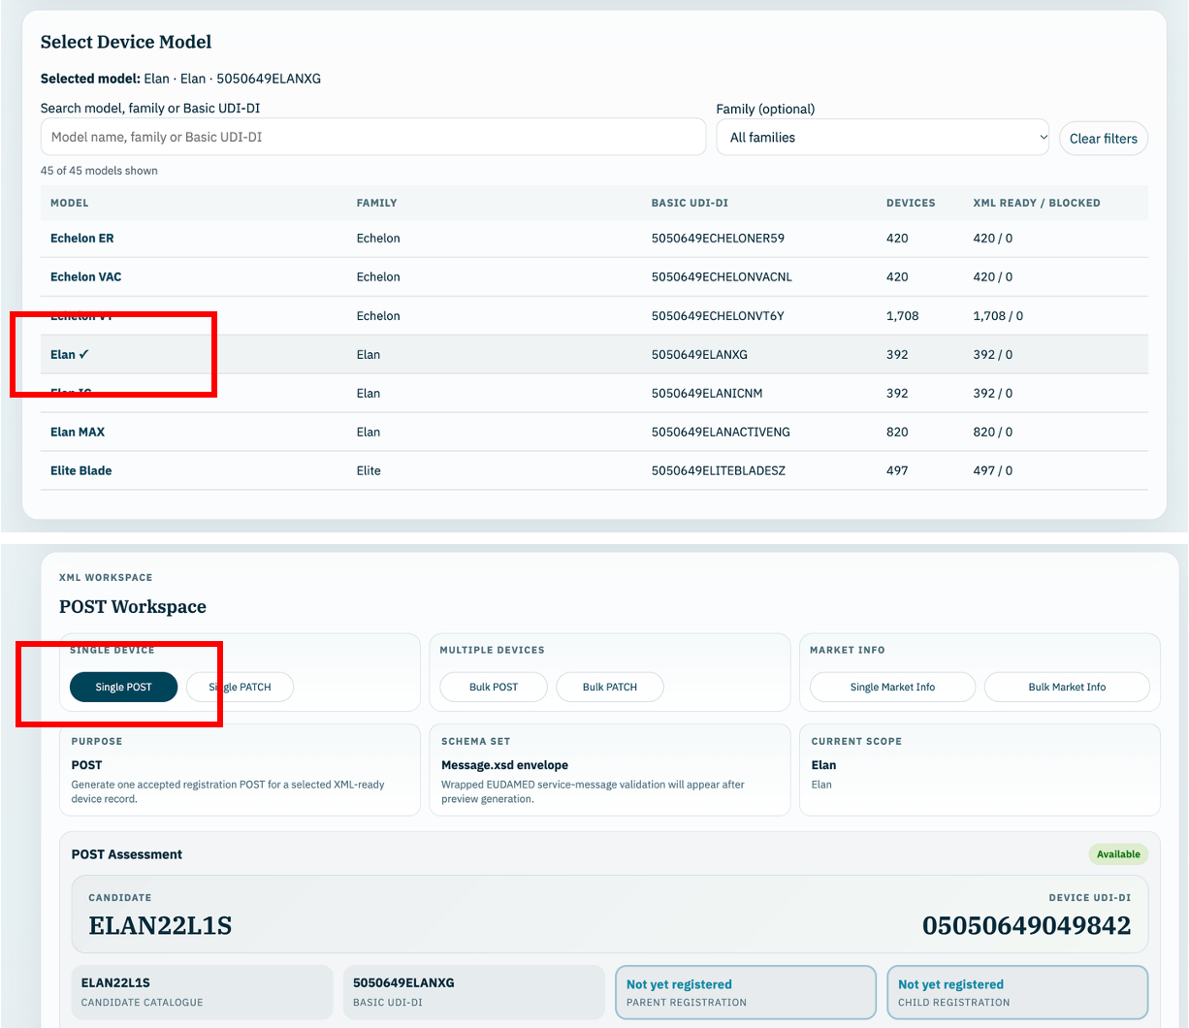

VP-05 — Bulk child registration
The image shows a registered Basic UDI-DI parent and child devices available for registration. The highlighted Bulk POST option is used to prepare their registration XML.
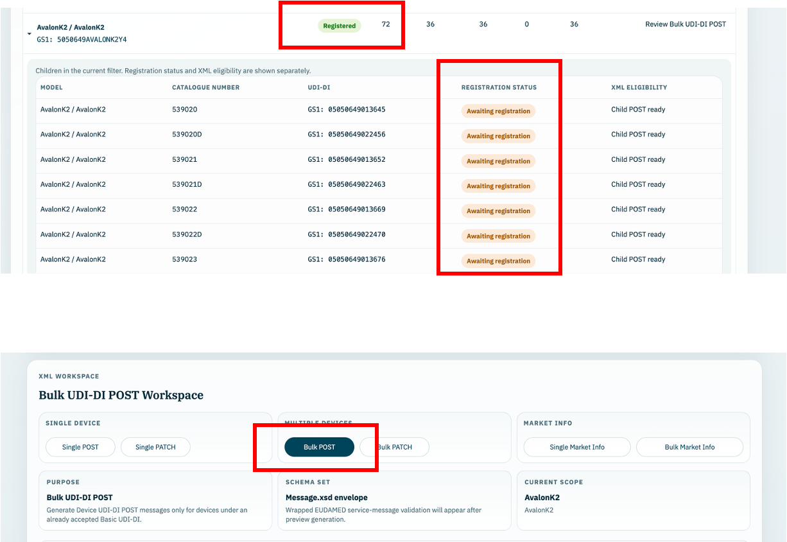

VP-06 — Single & Bulk PATCH
The images show selection of Bulk PATCH for a Basic UDI-DI parent and the update scenario to apply to its registered devices. Supported scenarios include storage conditions, trade name, critical warnings and base quantity. Single PATCH follows the same approach for one device.

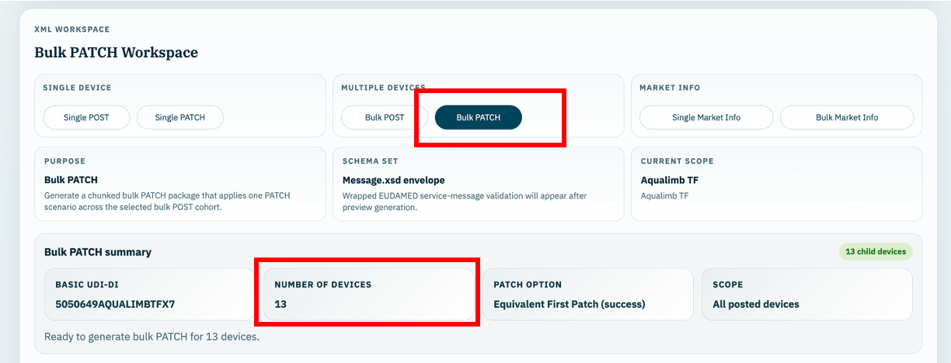

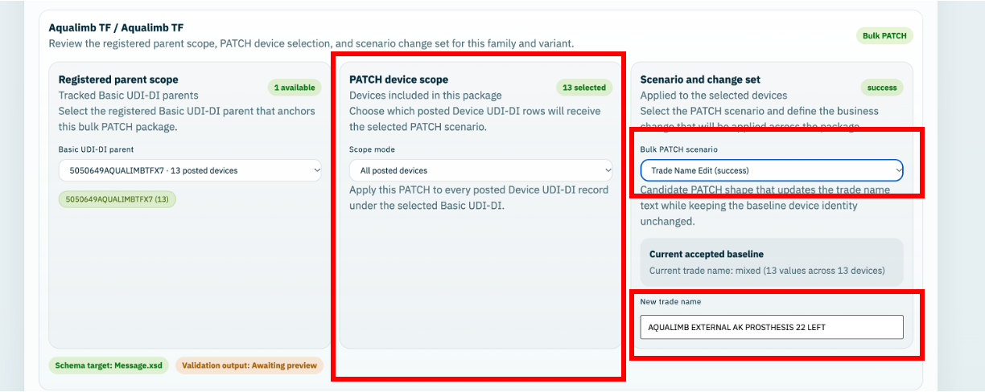

VP-07 — Single and bulk Market Information
The images show selection of Bulk Market Info for a Basic UDI-DI parent and changes to the countries recorded for the selected devices. The Operator can add or remove countries and review the proposed list. Single Market Info follows the same approach for one device.

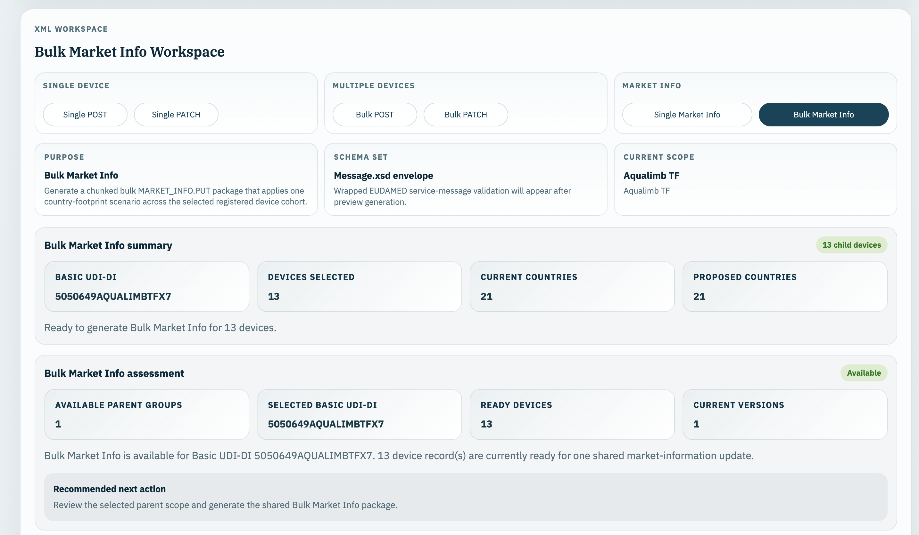

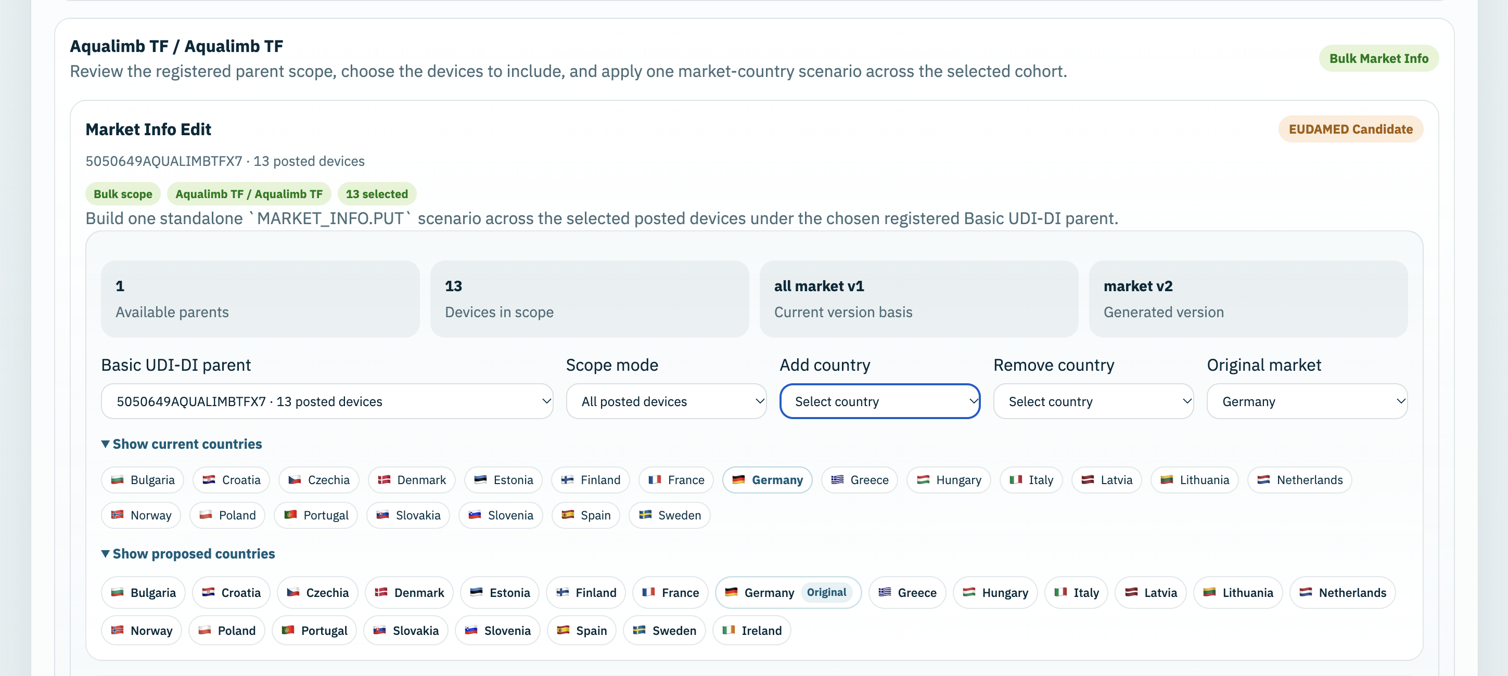

VP-08 — Package integrity and failure handling
The image shows the Single POST XML preview, structure navigation and schema-validation result. These controls support review of the generated XML before download and upload to the EUDAMED Portal. This screenshot illustrates the successful validation path; failure-handling evidence is recorded separately.
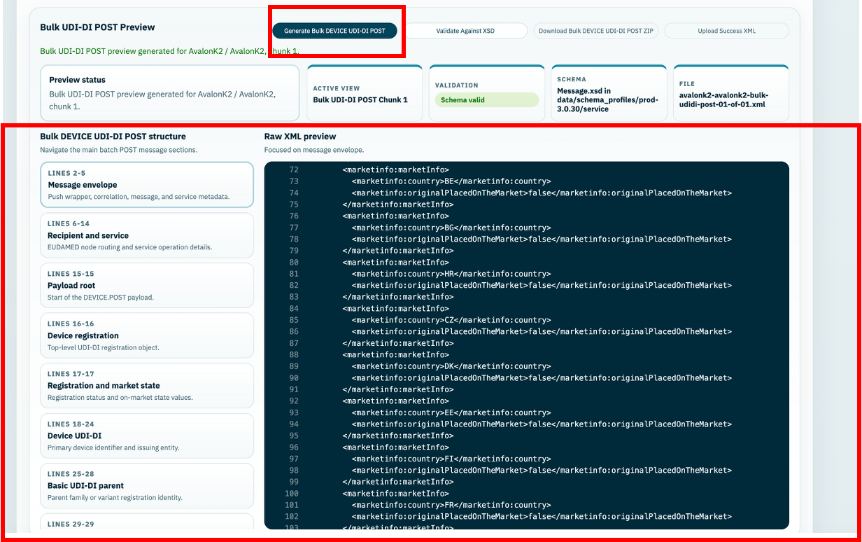

VP-09 — Acknowledgement matching and exceptions
The images show successful processing of uploaded XML in the EUDAMED Portal, the link to download the response XML, and the Loader’s Upload Success XML control. The Operator imports the response into the Loader to record the submission outcome. These images illustrate the response workflow; matching and exception-handling results require separate supporting evidence.
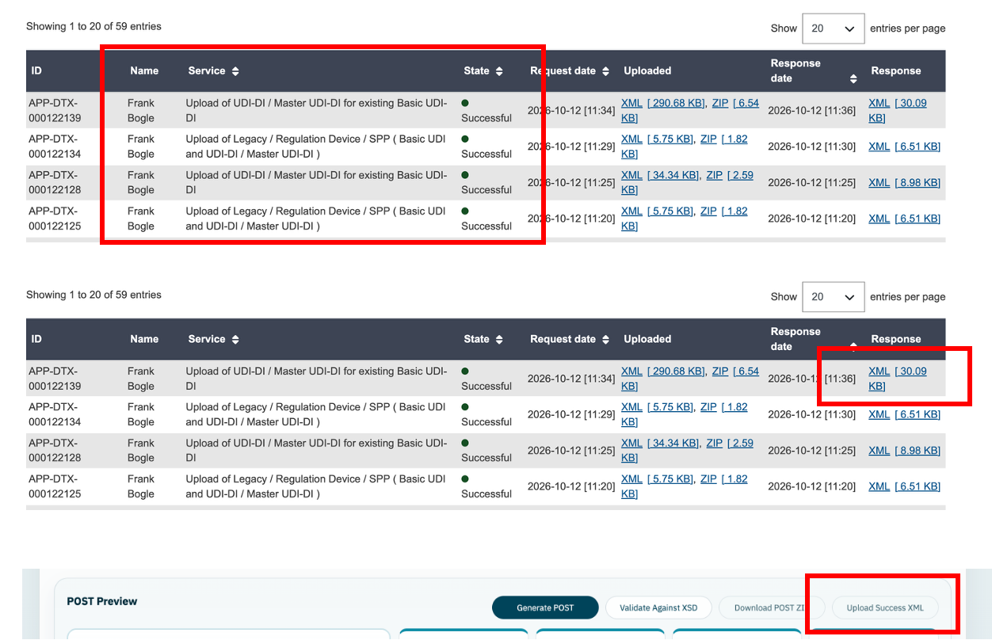

VP-10 — Read models and registration counts
The image shows Registration State, including the recorded SQLite snapshot and separate Basic UDI-DI parent and device registration totals.
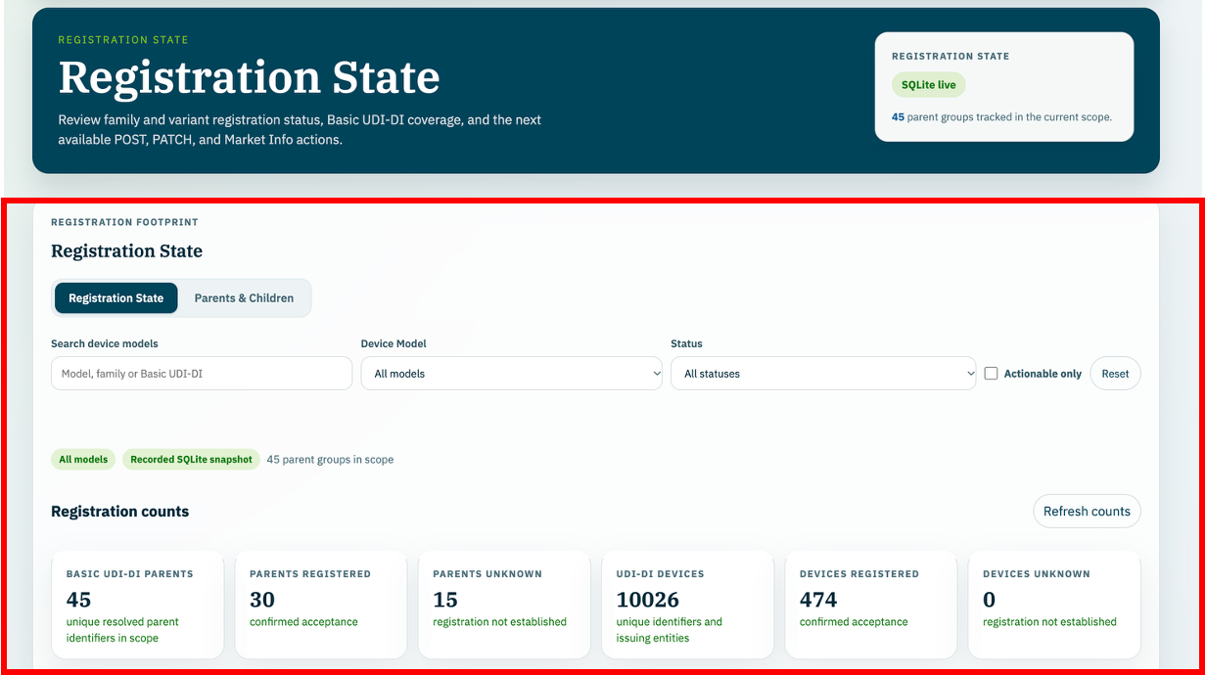

VP-11 — Recovery, retention and operational handover
The current Development Import Data workflow retains copies of uploaded Template Excel workbooks, the Basic UDI-DI workbook and EUDAMED XML extracts within the saved import and dated batch structure. These are linked to file fingerprints, review findings, the generated Import Workbook and audit information.
Successfully processed EUDAMED confirmation XMLs are retained as XML text in the active environment’s database, together with their filenames, identifiers and recorded outcomes.
For downloaded submission ZIP packages, the application records package metadata, manifests and integrity fingerprints, but does not retain the ZIP file itself.
Operators must retain the exact ZIP submitted to EUDAMED in the designated controlled location.
Retention periods and backup arrangements are governed by Blatchford document-control and IT policies, including those applicable to cloud-hosted resources. The application does not currently enforce a fixed retention period.

